Name : Dhruv Sharma Roll No: 16010421099 Batch: B1 Date: 22-08-23

Get Request code:

RequestForm.php:-

<html>

<body>
<form action="exp2.php" method="get">
Name: <input type="text" name="name">
Email: <input type="text" name="email">
<input type="submit" value="Submit">
</form>
</body>

</html>
exp2.php:-

Welcome
<?php echo $_GET["name"]; ?> |
Your email address is <?php echo $_GET["email"]; ?> <br>
Your Data Is Here:

OutPut:
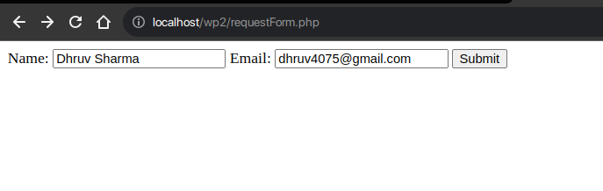
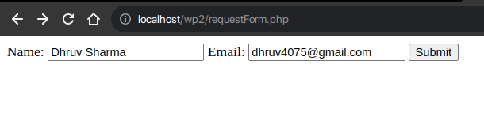
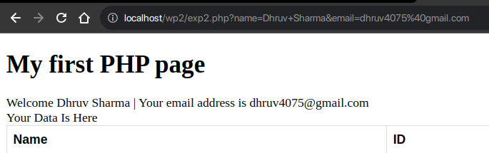

Post Method:

Code:

RequstForm.php:

<html>

<body>
<form action="exp2.php" method="post">
Name: <input type="text" name="name">
Email: <input type="text" name="email">
<input type="submit" value="Submit">
</form>
</body>

</html>

exp2.php:

Welcome <?php echo $_POST["name"]; ?> |
Your email address is <?php echo $_POST["email"]; ?> <br>
Your Data Is Here

Out Put:

Form:

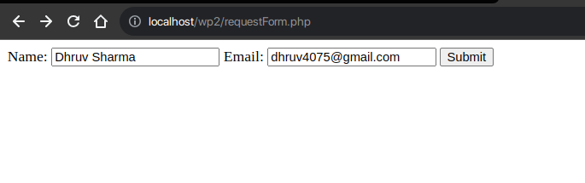
Second Page:

